Design of a 1 Liter Water Bottle with Revolving Cap Using Fusion 360

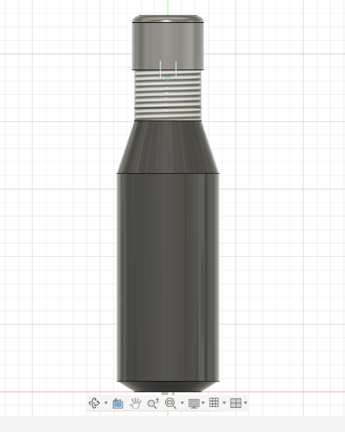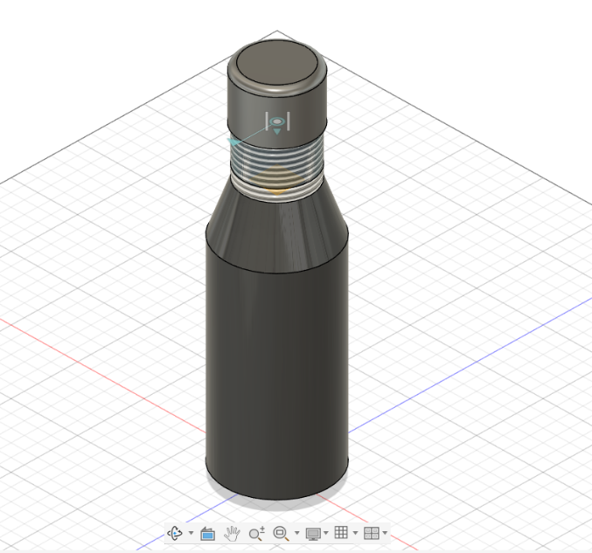

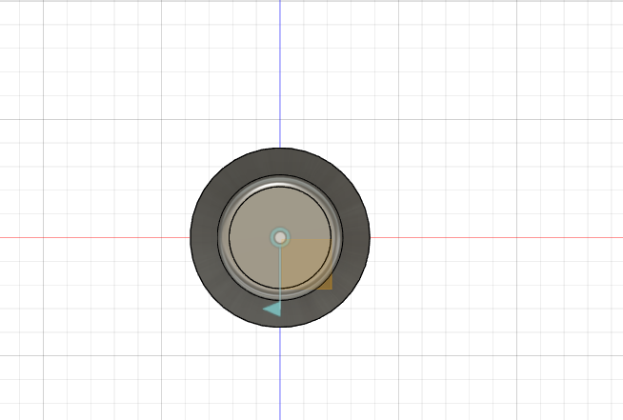

Description
This assignment focuses on the design and modelling of a 1 litter water bottle with a revolving cap using Fusion 360. The bottle was designed with an ergonomic cylindrical body, a tapered neck, and a threaded region to support smooth cap rotation.
The revolving cap mechanism allows easy opening and closing, improving user convenience and preventing leakage. The threading was carefully modelled to ensure proper alignment between the bottle neck and the cap. Features such as fillets and chamfers were applied to enhance aesthetics and reduce sharp edges.
The complete model was created using sketching, revolve, extrude, shell, thread, and assemble operations in Fusion 360. The final design represents a realistic and functional water bottle suitable for everyday use.

Outcomes
Through this assignment, the following skills and concepts were learned:
- Gained hands-on experience in 3D modeling using Fusion 360
- Learned to design revolving/threaded cap mechanisms
- Understood the importance of parametric design and dimensional accuracy
- Practiced assembly of multiple components in a single model
- Improved knowledge of real-world product design considerations
- Developed confidence in converting concepts into functional 3D models

